LESSON 2.

Morphology and ultrastructure of bacteria, the structure of the cell wall. Preparation of smears from various pathological materials and microbial cultures. Aniline dyes. Simple stain. Gram stain

LESSON PLAN:
- Classification of microorganisms
- General characteristics of bacteria.
- Classification and taxonomy of bacteria (concept of species, strain, etc.).
- Morphology of bacteria (cocci, rod-shaped, spiral and filamentous).
- Microscopic examination method.
- Stages of preparation of the smear.
- Method of degreasing glasses.
- Preparation of ointments from pus, sputum, blood and microbial culture.
- Drying the smear
- Fixation of the smear (physical, chemical, mixed).
- Aniline dyes, their classification by chemical composition and color
- Simple staining.
- Ultrastructure of bacterial cell. Stable (nucleoid, cytoplasm, ribosome, cell-cytoplasmic membrane, cell wall, mucous layer) and unstable (capsule, intracellular additions, flagella, plasmid, pili, spores) components of the cell.
- The structure of the cell wall of bacteria, Gram-positive and Gram-negative bacteria.
- Stages of Gram staining.

General characteristics of bacteria
Bacteria (Greek: bacteria) are single-celled microscopic organisms invisible to the naked eye.
They are prokaryotes.
Sedimentation of ribosomes is 70S
There are no nuclei, nuclear membranes and histones.
The chromosome is 1.
No mitochondria, lysosomes, Golci complex, endoplasmic reticulum. The cytoplasmic membrane does not contain sterols (except mycoplasma).
- Bacteria (Greek bacteria - bacillus) are single-celled, invisible to the naked eye, microscopic living organisms. The size is very small and is measured in micrometers (microns).
- 1 mkm = 10⁻³ mm =10⁻⁶ m
- 1 nm = 10⁻³ mkm =10⁻⁶ mm =10⁻⁹ m
- Most pathogenic bacteria range in length from 1.5 to 3 microns and in diameter from 0.6 to 0.8 microns.
- However, there are bacteria that are very large (the causative agents of gas gangrene - 4-8 microns in length, 1-1.5 microns in diameter) and very small (the causative agents of tularemia and brucellosis are measured in tenths of a micrometer).
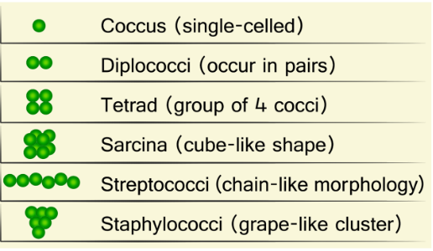
Morphology of bacteria:
Cocci, Rod-shaped bacteria, Spiral-shaped, Filamentous bacteria
- Rod-shaped bacteria or rods are rod-shaped.
- According to the location:
- single irregular - intestinal bacteria
- in pairs (diplobacilli) - klebsiella
- in the form of a chain (streptobacils) - the causative agent of anthrax
The ends of the cells:
- round
- truncated
- enlarged (fusibacteria)
According to their size:
- bacillus (spore-forming aerobic rod-shaped bacteria)
- clostridia (spore-forming anaerobic rod-shaped bacteria)
Microscopic method
- The microscopic method is based on the study of the morphological features of the perpetrators and their recognition.
- This method allows the detection of pathogens by microscopy in various test materials obtained from the patient, in the prepared native or stained smears.
- Morphological features of pathogens are studied by microscopy (identification based on morphological features) in native or stained prepared from cultures of microorganisms.
Degreasing of glass
- If the glass is freshly boiled in 1% soda solution and washed with water, it is kept in a weak solution of hydrochloric acid and washed again.
- Used glass is stored in a solid solution of sulfuric acid or a mixture of potassium-bichromate-water (100: 50: 1000) for 2 hours, washed with water and boiled in soda solution, washed again with water and wiped.
- It can also be degreased by wiping with dry soap and wiping with a clean cloth.
- When preparing the smear, to degrease it, hold the edge of the glass and pass it over the flame
Preparation of smear from pus and sputum
- Both glasses are degreased to make a paste of pus and mucus.
- Put a drop of material with a loop on one of them, put the second glass on the first, lightly squeeze, crush the tissue or material, make a smear by moving it in the opposite direction
- To prepare the "thick" drops - 1-2 drops of blood are placed on the glass and spread with a loop about 1 cm in diameter.
- Prepare to see parasites in the blood.
- "Thin" blood smear - 1 drop of blood is placed on the edge of a degreased glass and spread with another glass at an angle of 45 °.
- It is possible to determine the type of perpetrators.
Preparation of smear from bacterial cultures
- The right-handed bacteriological loop is heated to a flame.
- Put 1 drop of saline solution on the degreased glass.
- The test tube containing the microbial culture is held in the left hand (provided that the surface of the nutrient medium is visible). The stopper is removed with the index finger and palm of the right hand, the test tube and the stopper are passed through the flame.
- The material is taken by inserting the loop into the test tube
- The loop is removed, the test tube and the stopper are passed through the flame and closed.
- The microbial culture at the end of the loop is spread with saline on a glass 1 cm in diameter
- The bacteriological loop is heated in a flame
- The smears are mostly air-dried at room temperature.
- If it is thick, it can be dried in a thermostat or over a flame
- The object is dried over the flame by holding the edges of the glass (with the smear on top).
- Even if the smear is dried, the structure of the cell is not disturbed
- Blood smears should be dried at room temperature.
Smear fixation (physical, chemical, mixed)
Before staining, the sample must be heat fixed. This process accomplishes three things:
kills the bacteria
firmly attaches the smear to the microscope slide
allows the sample to more readily take up the stain
- During physical-thermal fixation, the smear is heated 3 times.
- It is fixed in chemical methyl alcohol - 5 minutes, ethyl alcohol and Nikifirov mixture - 10 minutes, in osmium acid vapor - 2-3 minutes, in formalin solution for a few seconds, in acetone - 5 minutes. Blood and organ smears are fixed.
- Physico-chemical-mixed fixation
Tinctorial feature of bacteria
- Tinctorial feature - the ability of bacteria to absorb dye solutions
- It is used in the morphological identification of bacteria
Aniline dyes. Dyes and their preparation
Chemical dyes are derived from coal and are called aniline dyes.
Most alkaline dyes are used.
Alkaline dyes stain the nucleus of the cell, while acidic dyes stain the protoplasm.
- Acidic (Acid fuchsin and eosin)
- Alkaline (Methylene blue, fuchsin, saffranin, neutral-rot, gensian-violet, vesuvin, chrysoidine)
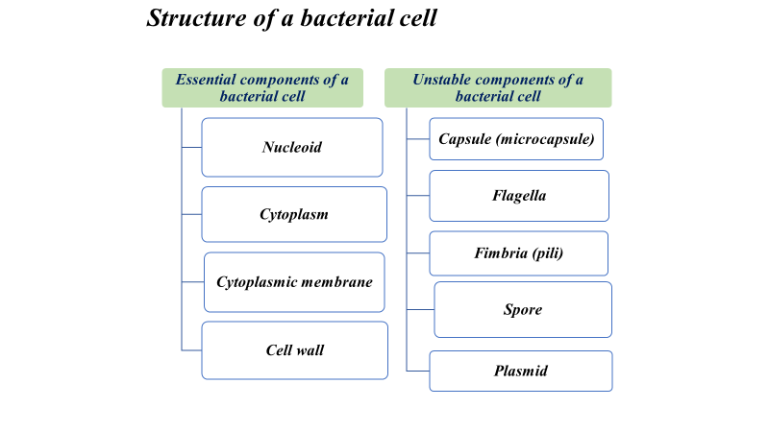
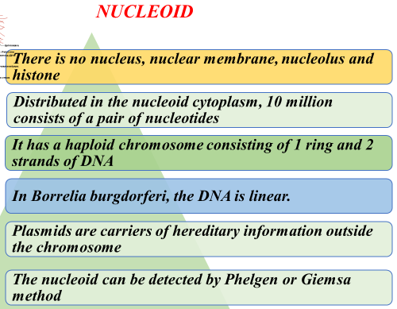
Cytoplasmic and intra-cytoplasmic addition
Cytoplasm - colloidal consistency, containing dissolved proteins, appendages and ribosomes (RNA).
The bacterium has a ribosome of 20 nm and a sedimentation constant of 70s (50s and 30s).
23s and 5s RNA in 50 sRNA.
16s RNA at 30 sRNA.
intra-cytoplasmic addition (glycogen, polysaccharides, lipids and polyphosphates) accumulate in the bacterial cell as a reserve nutrient and energy.
Bacterial cell membrane
The bacterial cell membrane consists of:
Cytoplasmic membrane
Cell wall
The mucous layer - an additional structure on the outside in some bacteria - is a capsule (slime factor, etc.).
Functions of the cytoplasmic membrane
- Regulates osmotic pressure
- Transmembrane proteins are responsible for signal transmission, and the lipid layer provides biological properties.
- Selectively, selectively conducts conductivity
- Provides transportation of substances by active transport mechanism
- Uses electronic transport system for breathing
- Contains biosynthetic and hydrolytic enzymes, transfer and signaling proteins
- There are specific binding sites for the bacterial chromosome and plasmids
- Inside the CPM, actin-like protein fibers are involved in the morphological formation of the bacterium. These fibers ensure that the treponema is spiral.
Cytoplasmic membrane
- No sterols (except mycoplasmas)
- The protein layer on the outside and inside (50-70%) is composed of 2 layers (bimolecular) lipids as the structure of the eukaryotic membrane.
- It is the main function of energy synthesis and electronic transport
- In the middle there are two layers of phospholipids (20-30%)
- Contains transpeptidase protein (PBP-penicillin binding protein)
- Mesasome is intussusception of the membrane into the cytoplasm, replacing mitochondria in more Gram-positive
- Central mesosomal DNA replication
- Lateral mesosome protein-enzyme synthesis
Cell wall
It is a protective layer surrounding the cytoplasmic membrane
- Gives shape to bacteriaIt has a barrier function
- Protects against osmotic lysis inside bacteria
- Provides contact with the host cell
- The host plays a role in the cell's fusion
- Can be determined by Gram method
- Plays a role in the pathogenesis of diseases caused by bacteria
- The cell wall is 10-20 nm thick and makes up 20-30% of the dry residue of the bacterial cell.
- The structure of the cell wall, which gives a stable shape to the bacterial cell, is quite complex. It is composed of several layers.
- According to the Gram method (named after Hans Christian Gram), the division of bacteria into two groups - Gram-negative and Gram-positive bacteria - is due to differences in the structure of the cell wall.
- The structure of the cell wall differs sharply in Gram-negative and Gram-positive bacteria.
The structure of the cell wall of Gram-positive bacteria
- In the cell wall of Gram-positive bacteria, peptidoglycan is combined with teichos acid (Greek, teichos-wall).
- Teichoic acid is a polymer composed of glycerol or ribitol linked by phosphate bonds.
- Peptidoglycan is bound by covalent bonds.
- Teichoic acid is soluble in water. Mammalian receptor or provides adhesion to other bacteria.
- Teichoic acid is one of the pathogenicity factors.
Structure of peptidoglycan:
- The peptidoglycan layer consists of a peptide (protein) and a glycan (polysaccharide).
- The residues of N-acetylglucosamine and N-acetylmuramic acids combine with glycosidic bonds to form a glycan molecule.
- Glycan molecules are located in parallel and are connected to each other through peptide bonds, forming layers.
- The N-acetylmuramic acids of two glycan molecules are joined by a transversal peptide bond through four amino acids (tetrapeptides), thus forming a peptidoglycan.
- In Gram-positive bacteria, the number of layers reaches 40 and makes up 50% of the cell wall.
- Gram-negative bacteria have only one to two layers and make up only 5-10% of the cell wall.
Gram negative cell wall
- Gram-negative cell wall is composed of
  - an outer membrane linked to thin, mainly single-layered peptidoglycan by lipoproteins
- The outer membrane includes
  - porins, which allow the passage of small hydrophilic molecules across the membrane
  - lipopolysaccharide molecules that extend into extracellular space
Gram-negative bacterial cell wall (outer membrane)
- The inner layer of the outer membrane is bounded by lipoprotein, and the outer layer is bound by lipopolysaccharide.
- The outer membrane of gram-negative bacteria differs significantly from other biological membranes due to its unusual conductivity.
- Due to its lipid nature, this membrane has hydrophobic properties. However, due to the presence of special pores (these pores are composed of special proteins called pores), some small-molecule hydrophilic substances - sugars, amino acids, etc. can enter the cell by passive diffusion.
Cell wall of Gram-negative bacteria (lipopolysaccharide - LPS layer)
- LPS consists of three fragments: lipid A, Core and O-specific.
- Lipid A consists of a glycolipid complex, which has a stable structure and is similar in all gram-negative bacteria.
- The core consists of two sugars, ketodesoxyoctanoic acid and heptose, similar to all gram-negative bacteria.
- The highly variable O-specific fraction consists of repetitive sequences of polysaccharides. This part is also called O-antigen due to its strong antigenic properties and can differ in each bacterial species, even within the species.
- Thus, the polysaccharide part of LPS provides antigenicity of bacteria, and the lipid part is thermostable and provides their toxigenicity (endotoxin).
Differences in the cell wall of Gram-positive and Gram-negative bacteria
- In Gram-positive bacteria, the cell wall is 50% (40-80%) of the dry mass, the cell wall is thick
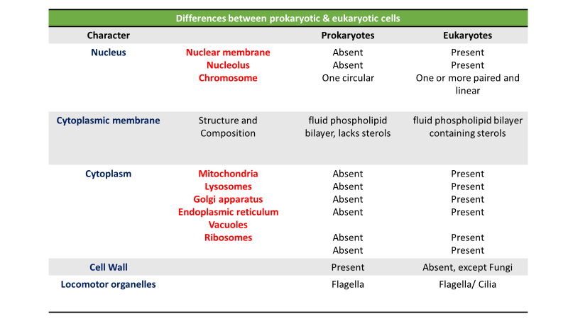
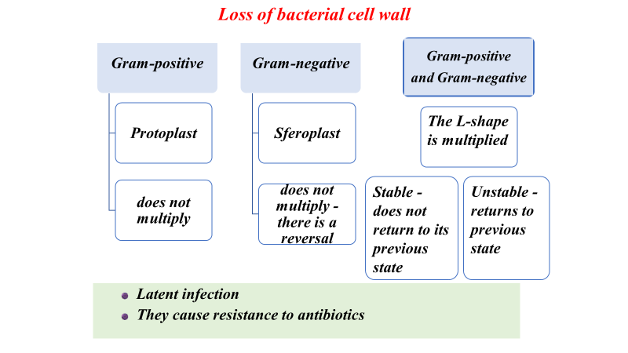
- In Gram-negative bacteria, the cell wall is 5-10% of the dry mass, which is thinner
Gram Staining Technique (Procedure)
1. Place slide with heat fixed smear on staining tray. Put a filter paper on the slide and add a crystal violet for about 1-2 minutes
2. Tilt the slide slightly and filter paper are discarded. Add Gram`s iodine solution for 1 minute.
3. Tilt the slide slightly and add alcohol for 30-40 seconds. Decolorize using 95% ethyl alcohol. Tilt the slide slightly and gently rinse with tap water.
Add safranin for 1 minute. Tilt the slide slightly and gently rinse with tap water. Allow the slide to dry with bibulous paper.
View the smear using a light-microscope under oil-immersion. Gram ( –) red, Gram (+) bacteria purple stained
Don`t stained with Gram stain
- Mycobacterium (due to high lipid content in the cell wall)
- Rickettsia ve Chlamydia (intracellular parasite and very small bacteria)
- Legionella pneumoniae (don’t stained with fuchsin)
- Mollicutes (lack cell wall-Mycoplasma)
- Treponema pallidum (very weak)

